Further Oral Activity: intended to address the relationship between language, meaning, and context.

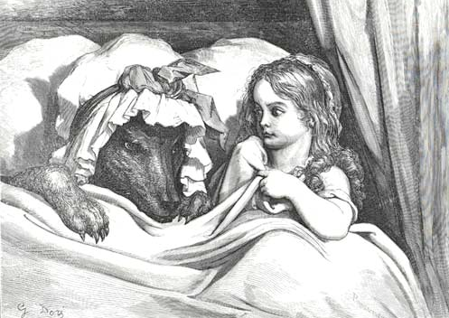
Students are required to engage in at least two further oral activities, one based on part 1 and one on part 2 of the course. The mark of the best activity is submitted for final assessment; the marks of the other activities must be recorded and kept by the school. The one in this unit is for the class grade and will not be recorded for IB.

You will be analyzing a fairy tale from the Brothers Grimm, two of the most well-known European storytellers. While there are many lenses that one can use to analyze literature, you will be responsible for providing a critique on the portrayal of gender roles and gender stereotypes in one of the Brothers’ fairy tales. You will also be responsible for analyzing your fairy tale and conducting your own research to gain further insight on the existence of traditional gender roles and stereotyping.

You will each speak for five minutes (10 minutes max for each presentation total, unless you are in a group of three), but how you use the time is up to each pair. Every pair must choose a fairytale different from that of the other pairs.

HL Students: For each fairytale chosen, you should analyze both gender roles and then apply your assigned logical fallacy to your discussion/presentation.
You can meet this goal in a variety of ways:
- Identify the fallacy within the text.
- Identify the fallacy in another version of the text (from a different culture, time period) and compare/contrast the versions.
- Identify the fallacy in a critique of the text.
- Use the fallacy in the presentation during a dramatic scene or during role playing.

At least the day before your presentation, you will each electronically turn in your own bibliography (MLA format) of the sources that you use for your presentation, and separately write your reflection to turn in. This must be retained by the school and may be required by the IB’s assessment operations department.

The reflection should include:
- An explanation of why you picked your chosen activity
- A plan for how you plan to answer both a unit question and a part 1 question
- A discussion of your argument (what you plan to prove)
- An understanding of how you will analyze language
- An organizational structure and an explanation of why it will be effective

Your grade is based on your delivery to the class and on the written texts that you submit.

Underpinning these activities is the issue of cultural and temporal context. Through the examination of the cultural or historical context of a text, including the way and the medium through which it is communicated, students will be able to engage with the process of intercultural and temporal understanding and thereby reflect on their own cultural or contemporary practices.

Examples of further oral activities
The following is a list of possible activities. This list is neither exhaustive nor compulsory. Please remember to make these presentations informative AND engaging.

Role play | Dramatic  presentation | Oral presentation
• A dialogue between characters or young children between two public figures with a follow-up discussion highlighting the way meaning is constructed  • A writer interviewed by the student as him/herself, or in another role (for example, a fellow politician)  • Advertising or public relations figures using language in a meeting to shape the view of a product, brand or public figure | • Writing and performing a satirical scene concerning an issue  • Re-enacting a particular cultural or historical moment with a different focus or interpretation in mind  A travel guide’s tour to the context  Singing and performing a ballad | • A formal speech from a parent  • A report, for example, comparing two fairytales  • An introduction to a particular topic, for example, the social and cultural contexts of a text  • The examination of a particular interpretation of a text or event  • The setting of a particular writer’s text against another body of material, for example, details on social background or political views  • An interactive lesson on the use of a particular image, idea or symbol in a text or texts studied  • A comparison of two texts  • An account of a student’s developing response to a text  • A presentation on image as text  • A presentation highlighting the codes used in a particular visual text

Below is a list of some of the better-known Brothers Grimm fairytales.

Rapunzel
Hansel and Gretel
Cinderella
Rumpelstiltskin
Little Brier-Rose
Little Snow-White
Little Red Cap
The Singing, Springing Lark
The Frog King
The Valiant Little Tailor
The Twelve Dancing Princesses
The Six Swans

